HOUSE OF DELEGATES MEETING
AMTA NATIONAL CONVENTION
DENVER, COLORADO
SEPTEMBER 17, 2014
By: Cathryn Forester, AMTA-KY 1st VP and 2014 Delegate

"Courage is what it takes to stand up and speak; courage is also what it takes to sit down and listen" - Winston Churchill.

These were the opening words of AMTA 2014 House of Delegates Meeting, reminding those present that the business of AMTA is important and impactful and that it should be conducted with decorum and respect.

Each year at the AMTA National Convention, the House of Delegates, made up of volunteer elected AMTA members from each state, meets to consider Position Statements that reflect AMTA’s stance on important massage therapy issues and Recommendations regarding bylaw changes and to vote on these matters, as well as on representation.

At the AMTA-KY 2014 Spring Conference, our members elected Delegates to the HOD. At the AMTA-KY 2014 Summer Meeting, members made their voices heard on three Recommendations and three Position Statements that were presented. Our members’ issues and concerns were then carried to the 2014 AMTA National Convention in Denver, CO in September where they were vigorously debated and discussed before being voted on by all AMTA Delegates. Here, then, are the results of the 2014 AMTA House of Delegates meeting:

POSITION STATEMENTS
Utah's position statement that “massage therapy can improve health and wellness through its effects on the physical, mental and social well-being of an individual” passed.

North Carolina’s position statement that “regulations, in statute and/or rules, should provide options for portability of credentials which meet the required licensing, certification, or registration of massage therapists across the United States” failed.

Virginia’s position statement that “massage therapy can assist in the rehabilitation of burn scars” failed.

IT IS THE POSITION OF THE AMERICAN MASSAGE THERAPY ASSOCIATION THAT MASSAGE THERAPY CAN IMPROVE HEALTH AND WELLNESS THROUGH ITS EFFECTS ON THE PHYSICAL, MENTAL AND SOCIAL WELL-BEING OF AN INDIVIDUAL.

CONTINUED ON NEXT PAGE…

POLICY CHANGE RECOMMENDATIONS

South Carolina’s recommendation to the AMTA National BOD to remove the financial responsibility of funding Delegates’ attendance to the House of Delegates from the State Chapters’ budgets passed.

Washington’s recommendation to the AMTA National BOD that they study moving the function of generating and approving Position Statements on the clinical efficacy of massage from the House of Delegates to another group, and that the AMTA BOD encourage the HOD to discuss issues that relate to the actual practice of massage therapy throughout the United States failed.

California’s recommendation to the AMTA National BOD to allow each Chapter to decide the amount of its Chapter Fee and how to request/acquire said Chapter Fee passed.

THE POLICY CHANGE RECOMMENDATIONS FROM SC REGARDING DELEGATES’ EXPENSES AND FROM CALIFORNIA REGARDING CHAPTER FEES WILL NOW BE CONSIDERED BY THE AMTA NATIONAL BOARD OF DIRECTORS, WHO MAY OR MAY NOT ACT ON THESE RECOMMENDATIONS, BUT WHO WILL REPORT BACK TO CHAPTERS THE RESULTS OF THESE CONSIDERATIONS.

NEW HOUSE OF DELEGATES OPERATIONS COMMITTEE MEMBERS WERE ELECTED:

RICHARD TESTA, CONNECTICUT
BARRY TERRY, MISSOURI
JESSICA FERRER, NEW HAMPSHIRE

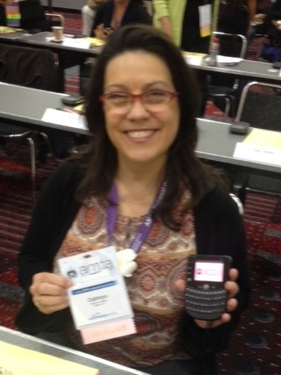
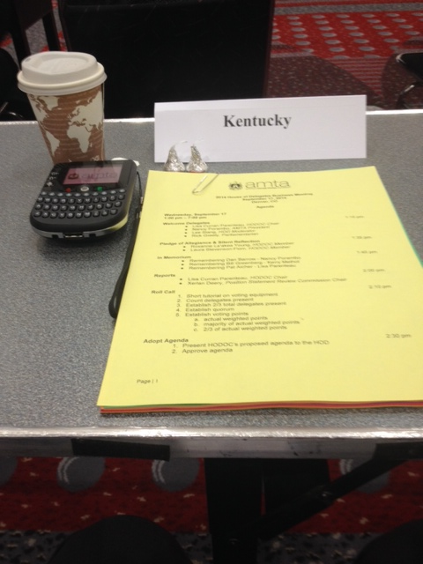

If you are interested in writing a Recommendation or a Position Statement for consideration at an upcoming AMTA House of Delegates Meeting, running for the position of Delegate, or learning more about the process, click on this link: http://www.amtamassage.org/chapters/House-of-Delegates.html

